Psychophysics Software Suite (PSS)
Developer Manual
Contents
Class Diagrams 2
Sound Classes 2
Sound Class – abstract basic class, all other sound classes inherit it methods and properties 3
GapSound Class – gapped sound 3
PureSound Class – pure tone sound 3
NoiseSound Class – noise based sound 4
AccordSound Class – accord (multiple tone) sound 4
ModulatedSound Class – AM or FM modulated sound 5
CreateGapSound Class – GUI applet for GapSound class constructor 5
CreatePureSound Class – GUI applet for PureSound class constructor 6
CreateNoiseSound Class – GUI applet for NoiseSound class constructor 6
CreateAccordSound Class – GUI applet for AccordSound class constructor 7
CreateModulatedSound Class – GUI applet for ModulatedSound class constructor 7
ChooseSound Class – GUI applet used to facilitate different Sound classes creation 7
Tools Classes 8
Tools Class – GUI applet facilitates the launch of PSS tools 9
CreateTest Class – GUI applet facilitates the creation and management of PSS tests 9
Analysis Tool Class – GUI applet facilitates the analysis of PSS tests 10
Test Class – software representation of PSS test 10
Block Class – software representation of PSS test’s block 11
Block State Machine Diagram 13
Delta change algorithm diagram 14
GUI Classes 15

Class Diagrams

Sound Classes
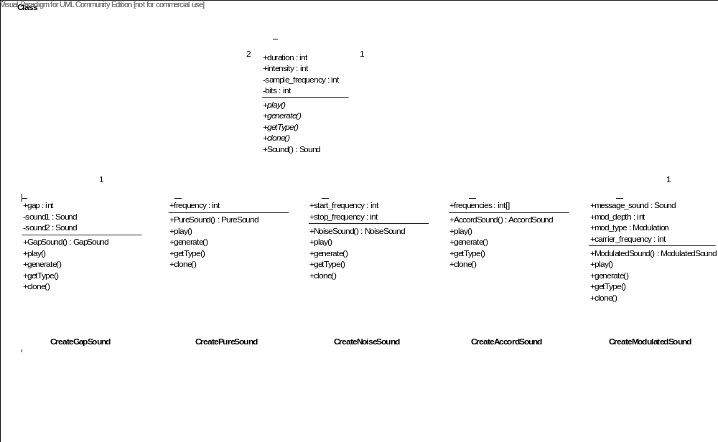

Sound Class – abstract basic class, all other sound classes inherit it methods and properties

Properties
- duration – sound’s playback duration in ms
- intensity – sound’s intensity, can vary from 0 to 1, when above one clipping occurring
- sample frequency – sample frequency of sound, default value 44000 Hz
- bits – sound’s bit resolution, the default value 16 bit

Methods
- play() – abstract function to play the sound
- generate() – abstract function to generate the sound’s data
- getType() – abstract function returns the sound’s type
- clone() – abstract copy-constructor
- Sound() – constructor

GapSound Class – gapped sound

Properties
- gap – gap duration in ms

Methods
- GapSound() – constructor
- play() – implementation of abstract function to play the sound
- generate() – implementation of abstract function to generate the sound’s data
- getType() – implementation of abstract function returns the sound’s type
- clone() – implementation of abstract copy-constructor

PureSound Class – pure tone sound

Properties
- frequency – tone frequency

Methods
- PureSound() – constructor
- play() – implementation of abstract function to play the sound
- generate() – implementation of abstract function to generate the sound’s data
- getType() – implementation of abstract function returns the sound’s type
- clone() – implementation of abstract copy-constructor

NoiseSound Class – noise based sound

Properties
- start_frequency – defines the start frequency of band-pass filter
- stop_frequency – defines the stop frequency of band-pass filter
Band –pass filter is based on Fourier transform. When both start_frequency and stop_frequency are zero, no filtering occurs. Noise sound is generated each time the sound needs to be played.

Methods
- NoiseSound() – constructor
- play() – implementation of abstract function to play the sound
- generate() – implementation of abstract function to generate the sound’s data
- getType() – implementation of abstract function returns the sound’s type
- clone() – implementation of abstract copy-constructor

AccordSound Class – accord (multiple tone) sound

Properties
- frequencies – tones’ frequency

Methods
- AccordSound() – constructor
- play() – implementation of abstract function to play the sound
- generate() – implementation of abstract function to generate the sound’s data
- getType() – implementation of abstract function returns the sound’s type
- clone() – implementation of abstract copy-constructor

ModulatedSound Class – AM or FM modulated sound

Properties
- sound – sound that used as data to be modulated , derived from Sound class
- mod_depth – depth (index) of the modulation ( see the formula below for details )
- mod_type – type of the modulation, can be either amplitude(AM) or frequency(FM) modulation
- mod_frequency – modulation frequency (Ω_{m})
AM modulation: x(t) = [1+ mod_depth ·sin (2π Ω_{m}t)] · sound
FM modulation: x(t) = cos [2π sound + mod_depth · sin (2π Ω_{m}t)]

Methods
- ModulatedSound() – constructor
- play() – implementation of abstract function to play the sound
- generate() – implementation of abstract function to generate the sound’s data
- getType() – implementation of abstract function returns the sound’s type
- clone() – implementation of abstract copy-constructor

CreateGapSound Class – GUI applet for GapSound class constructor
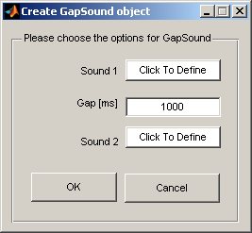

CreatePureSound Class – GUI applet for PureSound class constructor
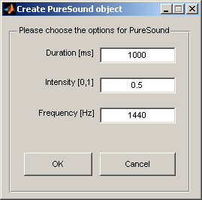

CreateNoiseSound Class – GUI applet for NoiseSound class constructor
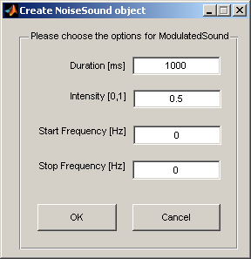

CreateAccordSound Class – GUI applet for AccordSound class constructor
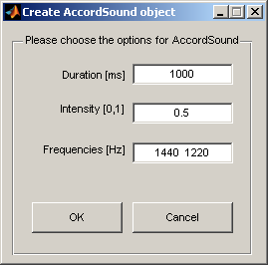

CreateModulatedSound Class – GUI applet for ModulatedSound class constructor
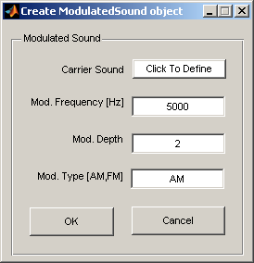

ChooseSound Class – GUI applet used to facilitate different Sound classes creation
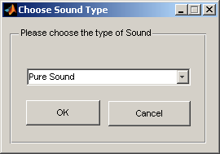

Tools Classes
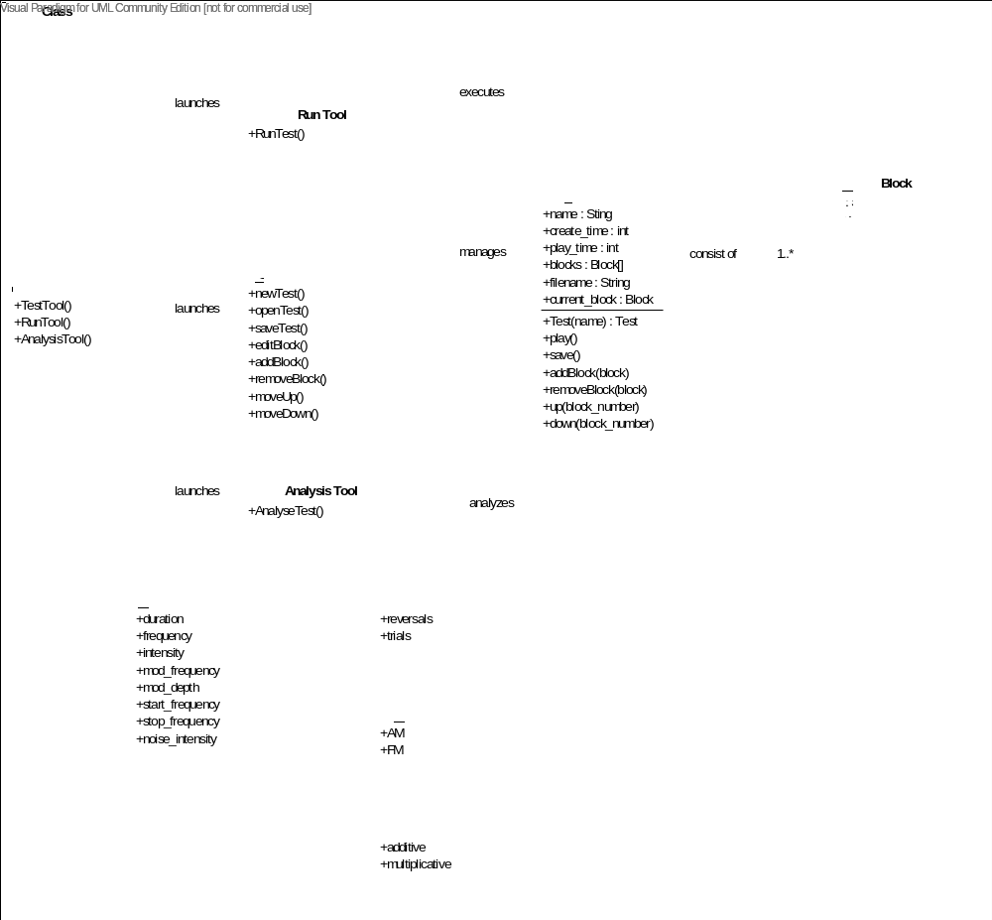

Tools Class – GUI applet facilitates the launch of PSS tools
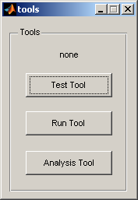

CreateTest Class – GUI applet facilitates the creation and management of PSS tests
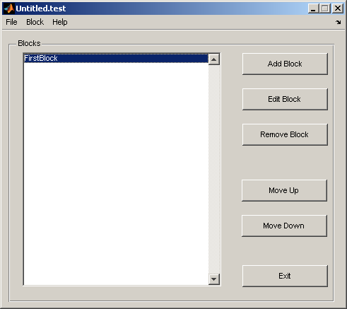

Methods
- newTest() – creates new PSS test
- openTest() – opens saved PSS test
- saveTest() – saves the current open PSS test
- addBlock() – adds the Block to PSS test
- editBlock() – enable the user to edit PSS test’s block
- removeBlock() – removes the selected block from the current PSS test
- moveUp() – places the selected block one position up in PSS test block’s list
- moveDown() – places the selected block one position down in PSS test block’s list
- exit() – exits the tool

Analysis Tool Class – GUI applet facilitates the analysis of PSS tests
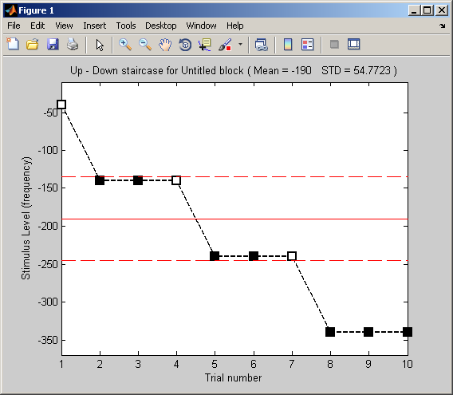

Test Class – software representation of PSS test

Properties
- name – name of the test
- create_time – time of the PSS test creation
- play_time – time of PSS test execution
- filename – name of the file to save the PSS test’s results
- blocks – array of Blocks that belong to this PSS test
- current_block – the currently processing Block

Methods
- Test(name) – Test class constructor
- play() – starts the test execution
- addBlock(block) – adds the block to the test
- removeBlock(block) –removes the block from the test
- up(block_number) – places the block one step up
- down(block_number) – places the block one step down
- save() – save all test data into filename file

Block Class – software representation of PSS test’s block

Properties
- name – name of the block , must be unique within the same test
- theme – theme of the block GUI
- test – the test that block belongs to
- reference_sound – reference sound of the block
- step_mode – the mode of block execution, may be additive ( delta parameter is added to the block‘s current value ) or mulplicative ( the block current value is multiplied by the delta parameter )
- based_on – specifies the parameter of the reference sound to be modified during the block execution
- start_at – the value the block will start with
- stop_at – the value the block will not exceed during its execution
- delta – the parameter that defines the amount of the block’s value change
- ISI – Inter Stimulus Interval
- ITI – Inter Trial Interval
- task – the string that defines block’s GUI options , has to be in ‘abx’ form
- big_step – specifies the number of big steps ( step may be both trial and reversal )
- intermediate_step – specifies the number of intermediate steps
- small_step – specifies the number of small steps
- total2end – specifies the number of total trials
- GUI – stores the reference to block’s GUI object
- current_delta – current block delta parameter
- current_value – current block value
- current_mode – current block mode , may be big, intermediate, small or end
- current_mode_steps – steps performed during current mode
- current_direction – specifies the current direction of value change, it may be up or down
- last_direction – specifies the last direction of value change, it may be up or down
- total_steps – the total number of steps performed up to present time
- correct_answers – number of correct answers to trigger the value change, default value is 3
- wrong_answers – number of incorrect answers to trigger the value change, default value is 1
- answers – an array to store the answers up to present time
- semaphore – a test’s field used to synchronize different blocks’ execution, was used due to lack of build in sync mechanism in Matlab

Methods
- Block(name) – Block class constructor
- start(code) – starts the block execution, if code=1 then the block is started in running mode, if code=0, then the block is initially paused
- stop(code) – if code=0 then pauses the block execution, if code=1 then the block and test execution is terminated
- play() – plays the current trial’s sounds
- check(answer) – checks if the answer selected by user is correct and modifies the current value accordingly.
- next(answer) – displays the GUI animation according to correctness of the answer and then plays the next trial’s sounds
- enableGUI() – enables the block’s GUI user accessible callbacks
- disableGUI() – disables the block’s GUI user accessible callbacks

Block State Machine Diagram
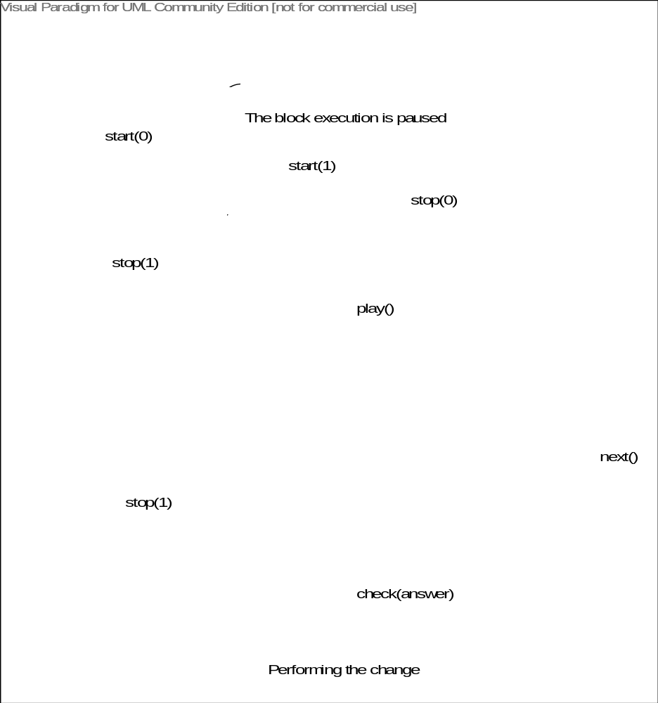

Delta change algorithm diagram
V>0
V<0
V>0
V<0
Add.
Mult.
V=V-D
V=V/D
Add.
Mult.
V=V+D
V=V/D
Add.
Mult.
V=V+D
V=V*D
Add.
Mult.
V=V+D
V=V*D
Answer
Correct
Wrong
Initial Values
V=start_at – reference_value
D=delta
Definitions
D – delta
V – current_delta
Add. – Additive delta change mode
Mult. – Multiplicative delta change mode

GUI Classes

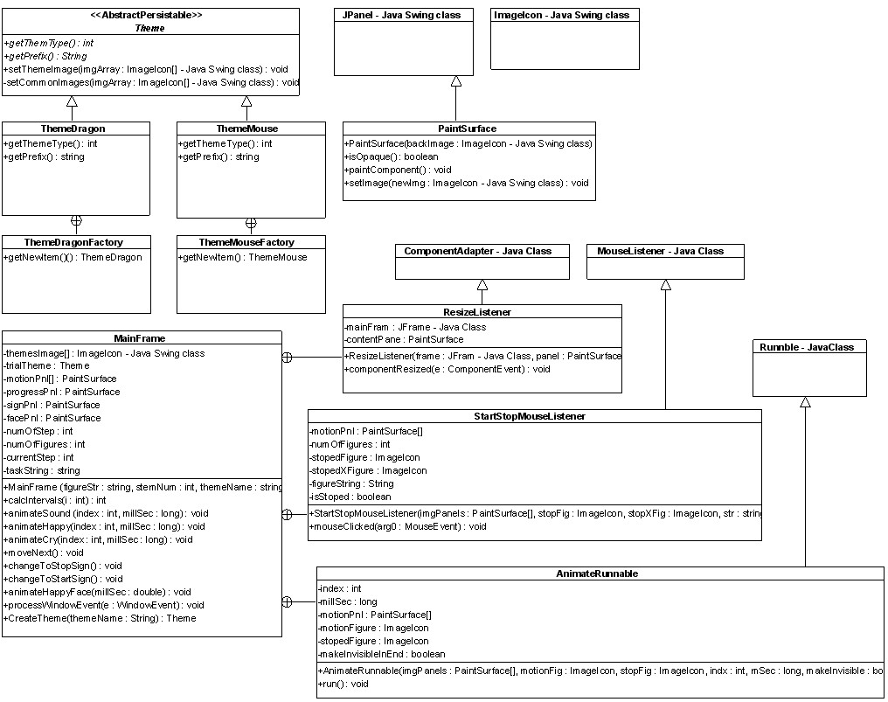
The description of GUI Classes diagram from above can be found here.

